Wise Words - March 9-16
Gary Wise
With a busy week of Tokyo testing (I even made a two day trip to Pittsburgh to do some work with Mike Turian and Car Acrobatic Team), articles for Sideboard Magazine and the beginnings of the Planeshift Limited analysis, I'd been putting off this week's column as long as possible, resulting in its lateness.
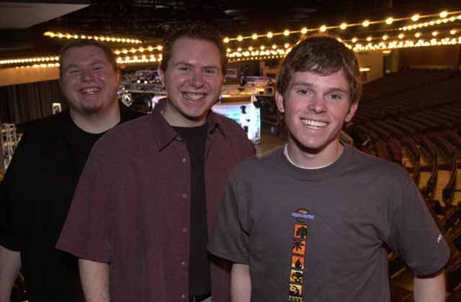
The big story of the week, at least from my perspective, has to be the roster change for the Tokyo Masters. Two weeks ago, Rolled Up Aces (Dan Clegg, Shawn Keller, Thomas Keller) was cruising, practicing for Team Rochester with Ben Rubin and other bay area players, secure in the knowledge that they'd be more than paying for their trip to Tokyo. There was an error in the ratings and they ended up not being invited.
The DCI isn't infallible. They made a mistake and as a result they had to fix that mistake, and I don't know that there was a better way to do it. In the past, when a team or individual has been erroneously invited to an event, they were included because their presence hurt no one except perhaps those they'd compete against directly, but the Masters is a new kind of tournament, and with it come new problems. With the Panzer Hunters successful appeal, they had one too many teams, and unfortunately, by tournament criteria, that meant the Aces had to go.
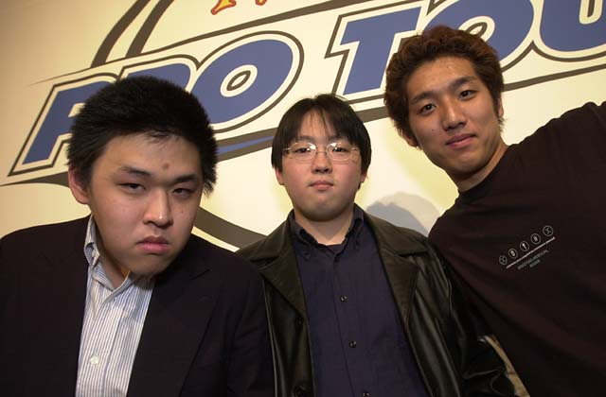
So now the question looms as to who the Hunters are. They made the finals, losing to AlphaBetaUnlimited.com, but where did they get their experience? All three members of the team have Pro Tour experience, with the obvious leader being Itaru Ishida. A veteran of ten individual Pro Tours, two Junior PTs and one team PT (DC), Itaru has long been one of Asia's top players, with his 13th place finish at PTLA '98 being the top finish for an Asian player until Satoshi Nakamura's recent finish at PTLA. He followed up that performance with a 25th place showing at PTNY that year but has since fallen on harder times.
Ishida's teammate Kazuyuki Momose was a finalist at GP Tohoku, and is a veteran of four Pro Tours, Both he and the team's third Reiji Ando, finished in the Top 8 at the 1999 APAC Championships and are described as 'strong, consistent players who were waiting for their big break' by Ron Foster, WotC's Territory Manager for Japan. This was it.
The Hunters qualified through their team rating despite the decision to not play at PTNY this year. Winners of one PTQ and finalists in another, the team chose to not make the trip that could have endangered their rating. Apparently their decision paid off.
On the other teams front, a big name free agent without a team has come to the forefront. Sigurd Eskeland, the Big Viking, has found himself without a team and is presently searching for two threshold types as partners for the next team PT. Sigurd, who won PTNY in April, has stated that he's willing to travel to American GPs in order to get some practice in, and should be eager to do well in that he'll need to replace those NY points if he wants to stay on the Masters.
With Meridian Magic's publishing of 'Random Guy's' article bashing and smashing Internet writers including yours truly, I asked a few trusted associates if they felt some of the things said in that article were accurate, specifically, whether it was felt I was catering to the lowest common denominator. When discussing this with play test partner Elijah Pollock, the answer I got back was interesting: He felt that I was actually catering to the Pro Tour inner circle, mostly because of the fact that quite often I was mentioning Pro players he'd never heard of.
The reason I act as 'gossip monger' with regards to PT goings on is that as a Sideboard writer, part of my job to promote the game in the most efficient way possible, and while there are many excellent writers who are more than capable of writing strategy articles, there aren't too many with as intimate an understanding of the PT and its players as I have. One reason that games like Baseball and Golf have flourished is because with the amount of exposure their stars get, people see them over and again and gain a basic familiarity that allows the spectator to identify with their favorite, in turn giving them a reason to watch and a reason to care. That's why I'm trying to promote the game's stars.
With that said, what follows are some brief profiles looking at some of the PT regulars you may not have heard of. Each of these players has fewer than two final day performances (with none this year) and at least 10 Pro Tour appearances on their resumes. Also, they are all in the top 50 in this year's Player of the Year race. This is to ensure that you guys know who I'm talking about when I mention them in the future.
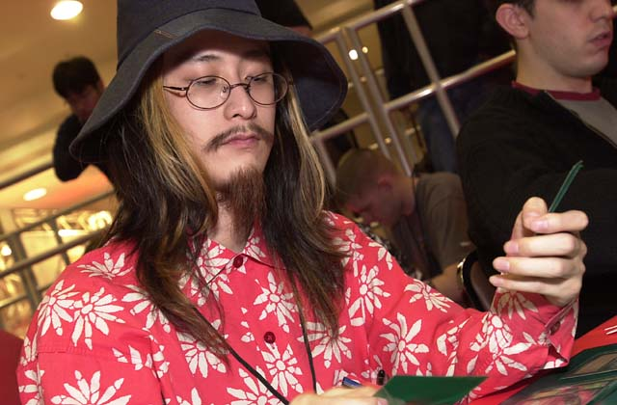
Satoshi Nakamura - Identifiable by his unusual hats and ice cream shaped erasers (used as counters and/or tokens), Satoshi is probably the best known Japanese player on Tour today (though he may quickly be replaced by Fujita, after Tokyo), with his most noteworthy accomplishments being his 11th place finish in this year's LA and his selection to the 1999 Duelist Invitational based on his victory at APACs that year.
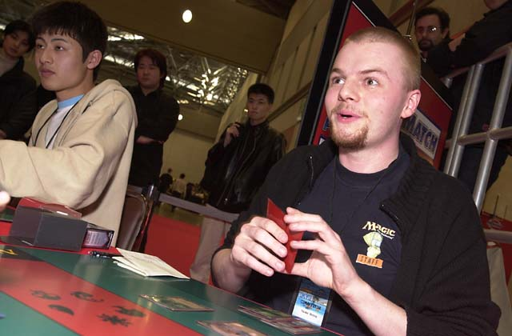
Nicolai Herzog - Another continental Champion, Nico made last year's Invitational on the strength of the second best DCI rating in Europe thanks to wins at Euro Championships '99, Norwegian Championships '99 and a Top 8 finish at Worlds '99 where he played Stompy. A member of Team Africa, Nico, a self-described Constructed specialist, has three Top 16 finishes since his Top 8 finish, as well as a 5th place finish at this year's Teams PT in New York. His team, Outland (which also includes Bjorn Jocumsen and Eivind Nitter) lost in the semifinals of Tokyo Masters to finalists Panzer Hunters.
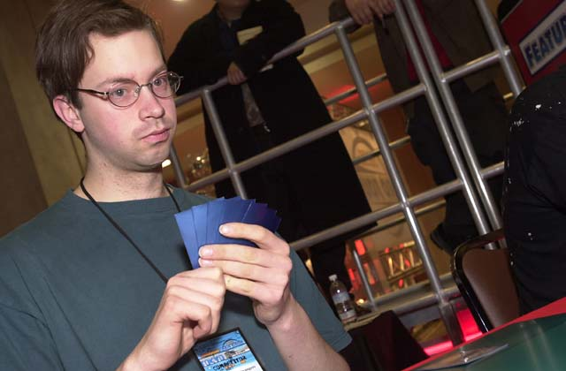
Bram Snepvangers - Making his debut at '97 Worlds, Bram Snepvangers has been a PT mainstay since the beginning of the 1998-99 season. Widely known for his unorthodox style that saw him first pick a Harrow over Distorting Wake at this season's Grand Prix Manchester, Bram is a major cog in the Dutch machine that has been establishing its country as a force in the world in Magic. More recognized as a Limited player than a Constructed one, Snepvangers' best performance came at this year's LA, where he finished tenth. Previously, his best performances came at PTLA '99, where he finished 18th, and GP Florence, where he came second.
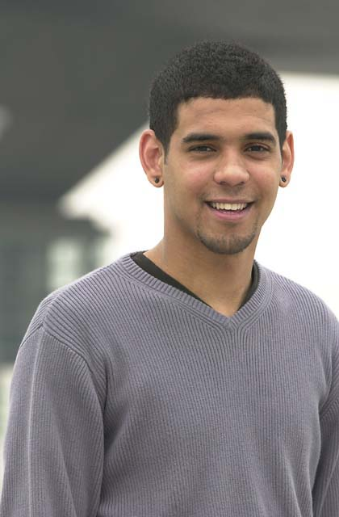
Dave Williams - If trash talk had a name, it would be Dave Williams. Williams is one of those players whose growing pains occurred while he played on Tour. Time and again he made his way to Pro Tours only to go home penniless, but finally after five tries, he scored some cash on Tour, and that's led to a pair of Top 32 finishes to go with 2 GP top 8s. Finally, in Tokyo, Williams came into his own, making his first PT Top 8. Williams' favorite psychological tactic is to knock his deck for the card he already has in hand and then run around the room screaming upon drawing his card. The result is usually psychological decimation.
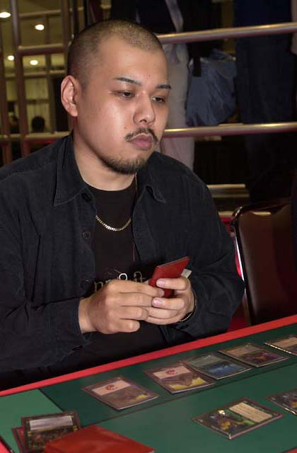
Masayuki Higashino - With 8 individual PTs to his credit, Masayuki's best finish is a 46th place finish at PTLA '99. Where he really shines however is the Grand Prix circuit, where he has four Top 8 finishes in the last two years, including wins at Tohoku and Hiroshima. Higashino held the privilege of representing Japan as its National Champion the year World Championships was held there, 1999.
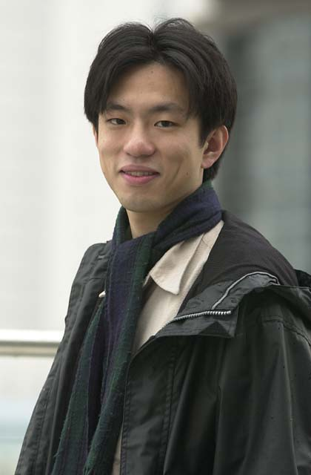
Tsuyoshi Fujita - A teammate of Higashino in both team PTs, Fujita ranks highly in this year's Player of the Year race thanks to his win at GP Kyoto and his amazing second place showing in Tokyo. Fujita has eight singles PTs to go with his two teams appearances, the best of which was coming in second over the weekend - marking the first time a Japanese player has made the Top 8.
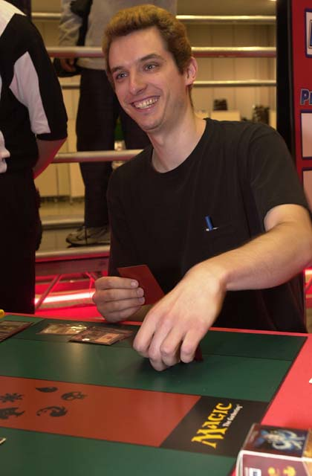
Matt Vienneau - Way back before time began, Vienneau was considered one of the Pro Tour's rising stars, with high money finishes in Columbus and Atlanta, where he made his lone Top 8. For the past few years, his performances have been quiet ones even if his articles have been the opposite, but as of late he's been having an awakening, with his win at GP Dallas being followed up by his final four finish at GP Boston. A veteran of over 20 PTs, Vienneau is presently looking for a team, with long time partner Gary Krakower having recently fallen off the gravy train.
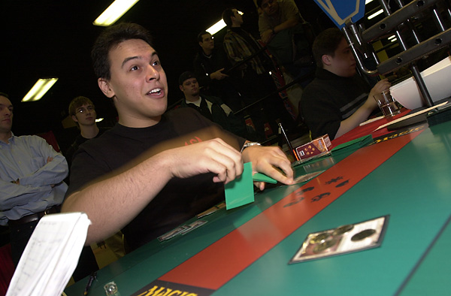
Justin Gary - One of the Tour's most consistent performers, Justin is the only player in PT history aside from Jon Finkel to score an amazing seven consecutive Top 32 finishes, with his 6th place finish in Rome marking the beginning of that streak. The one at-large member of team YMG, Justin also has a US Championship belt on his resume, and will be doing thesis work on the Magic community starting next year.
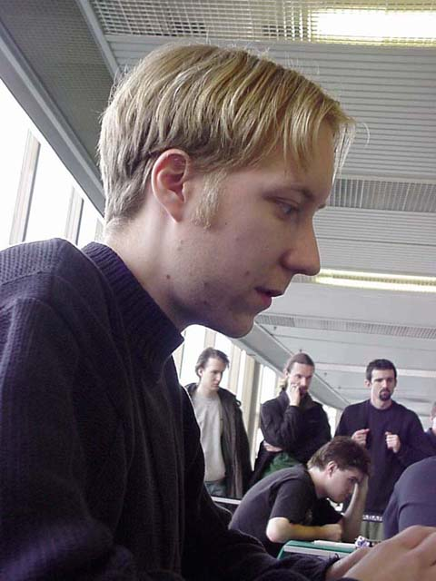
Mattias Jorstedt - Originally a member of the European Alliance, Mattias is now a core member of Team Reject, who had a very strong showing in Chicago. One of Europe's best deck builders, Mattias doesn't have a Top 8 finish but a number of near misses suggest that he's due. Jorstedt is most often seen hanging out with countryman Mattias Kettil.
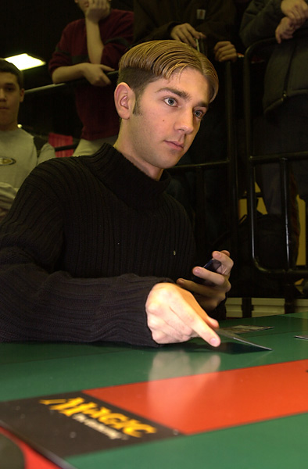
Jamie Parke - A veteran of the Junior PT, Jamie has literally grown up with the Pro Tour. With his lone Top 8 coming at 1999 World Championships, Jamie has not had a ton of PT success, but is regarded as a strong player. Jamie spends most of his time on the Tour with Sped teammates like Joe Weber, but he's been around long enough that any American player who's been around for a while has probably hung out with the Syracuse native.
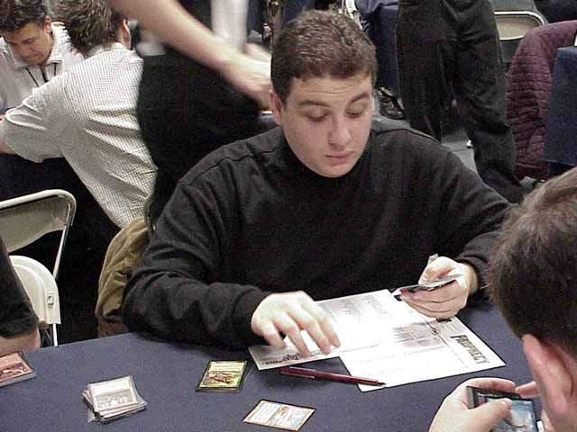
Dan OMS - Best known for his Antarctica affiliation with his little brother Steve and Jon Finkel, Dan has been a PT mainstay for years. Making the commitment this year to go to GPs outside North America, Dan has established friendships with other players who do the same, like Dave Williams and James Stroud. His best individual performance came at GP Copenhagen, where he lost the finals to Niels Jensen.
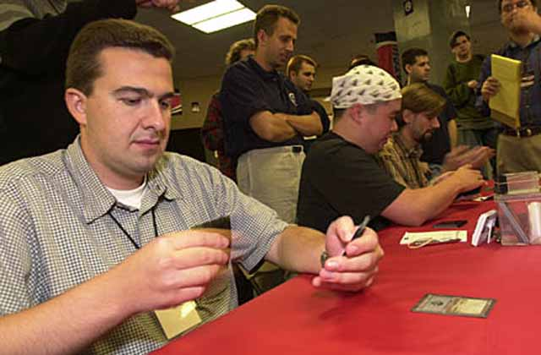
Igor Frayman - One of the old school legends, Igor has been around for a long time, playing in 21 Pro Tours. Most often seen teaming with Gab Tsang, Brian Hacker and Sigurd Eskeland, Igor has yet to capture that elusive Top 8. In waiting for that day to come however, the big Russian, has a pair of Limited Top 16 finishes to go with his 7th place finish at this year's Teams PT in New York, where he teamed with Hacker and Tsang to form B.I.G.
That's it for this week. As always, feel free to send questions or comments to JgaryWise@yahoo.com, though I'd appreciate it if you could keep them focused on the content of this column. Have a good week.

